VOICE ACTIVATED ELECTRONICS

# A PROJECT REPORT

***Submitted by***

***ABITHA M (210701011)***

***ADITI S (210701016)***

***AGNES C (210701019)***

***in partial fulfilment for the award of the degree of***

# BACHELOR OF ENGINEERING IN

**COMPUTER SCIENCE RAJALAKSHMI ENGINEERING COLLEGE**

# THANDALAM





**MAY 2024**

**BONAFIDE CERTIFICATE**

This is to certify that this project report titled **“VOICE ACTIVATED ELECTRONICS**” is the bonafide work of **“ABITHA M (210701011), ADITI S (210701016)** and **AGNES C (210701019)”** who carried out the project work under my supervision.

### SIGNATURE

**MR.S.SURESH KUMAR,M.E.,(Ph.D.),**

**SUPERVISOR**

Professor

Department of Computer Science and Engineering Rajalakshmi Engineering College

Chennai - 602 105

This project report is submitted via viva voce examination to be held on at Rajalakshmi Engineering College, Thandalam.



# ACKNOWLEDGEMENT

First and foremost, I acknowledge the amazing Grace of God Almighty, who blessed my efforts and enabled me to complete this thesis in good health, mind, and spirit.

I am grateful to my Chairman **Mr.S.Meganathan**, Chairperson **Dr.Thangam Meganathan**, Vice Chairman **Mr.M.Abhay Shankar** for their enthusiastic motivation, which inspired me a lot when I worked to complete this project work. I also express our gratitude to our principal **Dr.S.N.Murugesan** who helped us in providing the required facilities in completing the project.

I would like to thank our Head of Department **Dr. P. KUMAR** for his guidance and encouragement for completion of project.

I would like to thank **MR.S.SURESH KUMAR M.E.,(Ph.D.),** our supervisor for constantly guiding us and motivating us throughout the course of the project. We express our gratitude to our parents and friends for extending their full support to us.

**ABITHA M (210701011) ADITI S (210701016) AGNES C (210701019)**

**iii**

# ABSTRACT

Voice activated electronics, an innovative and increasingly prevalent technology, has transformed the way we interact with our living spaces. This abstract provides a concise overview of this concept. Smart home assistants are AI-powered devices or applications equipped with voice recognition capabilities, enabling users to control and manage a wide range of smart devices and services within their homes using natural language commands. These assistants offer convenience, automation, and personalization, allowing users to control lighting, heating, and entertainment systems, access information, and perform various tasks seamlessly. Key features include voice control, compatibility with multiple smart home ecosystems, and continuous learning from user interactions. They enhance daily life by simplifying routine tasks, improving energy efficiency, and ensuring accessibility for all users. As these devices continue to evolve, they play an integral role in the ever-growing ecosystem of smart homes, promising to make daily life more convenient and connected. In particular, voice-activated electronics for fans and lights have become a hallmark of modern smart homes. These systems allow users to adjust fan speeds and lighting intensity effortlessly through voice commands, adding a new level of convenience and customization to home environments. With simple spoken instructions, users can turn lights on or off, dim them to preferred levels, or set them to follow schedules that match daily routines. Similarly, smart fans can be controlled to provide optimal comfort, enhancing energy efficiency and personal comfort. This integration of voice-activated electronics not only improves user experience but also contributes to a more intuitive and responsive living space, further embedding smart home assistants into the daily lives of users.

**iv**

# TABLE OF CONTENTS

|  |  |  |
| --- | --- | --- |
| **CHAPTER NO** | **TITLE** | **PAGE NO.** |
|  | **ACKNOWLEDGEMENT** | **iii** |
|  | **ABSTRACT** | **iv** |
|  | **LIST OF FIGURES** | **vii** |
|  | **LIST OF TABLES** | **viii** |
|  | **LIST OF SYMBOLS** | **ix** |
|  | **LIST OF ABBREVIATIONS** | **x** |
| **1** | **INTRODUCTION** | **1** |
| 1.1 | INTRODUCTION | 1 |
| 1.2 | PROBLEM STATEMENT | 2 |
| 1.3 | SOLUTION | 2 |
| 1.4 | SUMMARY | 3 |
| **2** | **LITERATURE SURVEY** | **5** |
| 2.1 | EXISTING SYSTEM | 7 |
| 2.2 | PROPOSED SYSTEM | 8 |
| **3** | **SYSTEM SPECIFICATION** | **9** |
| 3.1 | SYSTEM ARCHITECTURE | 9 |
| 3.2 | REQUIREMENT SPECIFICATION | 10 |
| 3.3 | COMPONENTS USED | 10 |
| 3.4 | WORKING PRINCIPLE | 12 |

|  |  |  |
| --- | --- | --- |
| **4** | **RESULT AND DISCUSSION** | **13** |
| 4.1 | ALGORITHM | 13 |
| 4.2 | IMPLEMENTATION | 14 |
| **5** | **OUTPUT** | **16** |
| 5.1 | OUTPUTS | 16 |
| 5.2 | SECURITY MODEL | 17 |
| **6** | **CONCLUSION AND FUTURE WORK** | **18** |
| 6.1 | CONCLUSION | 18 |
| 6.2 | FUTURE WORK | 19 |
|  | **REFERENCES** | **21** |
|  | **APPENDIX** | **22** |

**LIST OF FIGURES**

|  |  |  |
| --- | --- | --- |
| **FIGURE NO.** | **NAME OF FIGURES** | **PAGE NO.** |
| 3.1 | System Architecture | 11 |
| 5.1 | Output | 18 |

# LIST OF TABLE

|  |  |  |
| --- | --- | --- |
| **TABLE NO.** | **NAME OF TABLE** | **PAGE NO.** |
| 4.1 | Components Table | 14 |

**LIST OF SYMBOLS**

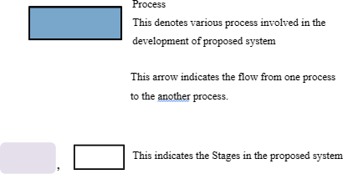

# ABBREVIATIONS

1. IoT - Internet of Things
2. SDK - Software Development Kit
3. IDE - Integrated Development Environment
4. Wi-Fi - Wireless Fidelity
5. LED - Light Emitting Diode
6. CAD - Computer-Aided Design
7. API - Application Programming Interface
8. USB - Universal Serial Bus
9. GPIO - General Purpose Input/Output 10.MCU - Microcontroller Unit

## CHAPTER 1 INTRODUCTION

* 1. **INTRODUCTION**

In the dynamic realm of technological evolution, the convergence of voice-activated electronics with the Internet of Things (IoT) represents a groundbreaking symbiosis that is reshaping our interaction with the digital world. This transformative alliance empowers users to engage with their devices in an unprecedented manner, heralding an era of intuitive and hands-free control. Voice activation, underpinned by sophisticated voice recognition algorithms, enables individuals to effortlessly command an extensive array of smart devices, ranging from household appliances to wearable gadgets. As we navigate this amalgamation of voice activation and IoT, the horizon unfolds with unprecedented possibilities. This collaboration holds the promise of elevating efficiency, enhancing accessibility, and redefining the user experience. In this era of seamlessly connected and intelligently responsive electronics, our surroundings stand poised to heed the nuances of our voice, ushering in a future where technology seamlessly aligns with human intent. The integration of voice-activated electronics extends to various domains, including home automation, healthcare, and personal fitness. For instance, voice-controlled smart lights and fans allow users to create customized ambiances and comfortable environments without lifting a finger. In healthcare, voice commands can help manage medical devices and provide real-time updates on patient status, facilitating better care and monitoring. Wearable gadgets, such as smartwatches and fitness trackers, utilize voice activation to offer hands-free interaction, making it easier for users to track activities.

### PROBLEM STATEMENT:

The Design and implement a voice-activated electronics control system using Internet of Things (IoT) technology, aiming to enhance user convenience and efficiency in home automation. The system should seamlessly integrate with various household devices, enabling users to control lights, appliances, and other smart devices through natural language voice commands. The solution should prioritize security, scalability, and real-time responsiveness, providing a 7 reliable and user-friendly interface for a smart home environment. Address challenges related to noise interference, multiple user recognition, and energy efficiency, while ensuring compatibility with popular voice recognition platforms. The goal is to create an intelligent, interconnected ecosystem that optimizes user experience and promotes sustainable and intuitive home automation.

### SOLUTION:

To address the outlined requirements, our solution proposes a comprehensive system architecture integrating cutting-edge IoT technology with robust voice recognition capabilities. At its core, the system will feature a centralized IoT hub responsible for managing communication between various smart devices and the voice recognition module. Leveraging state-of-the-art voice recognition platforms such as Amazon Alexa or Google Assistant, users will effortlessly command their smart home ecosystem using natural language voice commands.

To ensure security and scalability, our system will implement industry-standard encryption protocols and adhere to best practices in network security. Real-time responsiveness will be achieved through optimized communication protocols and efficient device management algorithms, guaranteeing swift execution of user commands.

Challenges related to noise interference and multiple user recognition will be mitigated using advanced noise cancellation algorithms and machine learning techniques. Moreover, energy efficiency will be prioritized through smart scheduling algorithms and device optimization strategies, promoting sustainable usage patterns.

The user interface will be designed with a focus on simplicity and intuitiveness, offering both mobile and web-based platforms for seamless control and configuration of the smart home environment. Compatibility with popular voice recognition platforms will be ensured, allowing users to leverage their preferred voice assistant seamlessly.

Overall, our solution aims to create an intelligent, interconnected ecosystem that not only enhances user convenience and efficiency but also promotes sustainable and intuitive home automation experiences.

### SUMMARY:

Our proposed voice-activated electronics control system embodies the pinnacle of innovation in home automation, offering users unparalleled convenience and efficiency. By seamlessly integrating with a wide array of household devices, from lights to appliances, users can effortlessly orchestrate their living spaces with natural language voice commands. Security is paramount, with robust measures in place to safeguard user data and privacy. The system is designed with scalability in mind, capable of accommodating the evolving needs of any smart home environment. Real-time responsiveness ensures prompt execution of commands, while intuitive interfaces make the system accessible to users of all levels of technical proficiency. Addressing challenges such as noise interference and multiple user recognition, our solution employs advanced algorithms and machine learning techniques. Moreover, energy efficiency is a core focus, with smart scheduling and optimization strategies employed to minimize environmental impact. By ensuring compatibility with popular voice recognition platforms, our system seamlessly integrates into existing smart home ecosystems, promising to transform the way users interact with their homes while promoting sustainability and intuitive automation.

Our voice-activated electronics control system leverages IoT technology to streamline home automation, enabling users to effortlessly command their smart devices through natural language voice prompts. With an emphasis on security, scalability, and user-friendly design, our solution promises to redefine the smart home experience, making daily tasks more intuitive and efficient.

Our solution is a cutting-edge voice-activated electronics control system, leveraging IoT technology to revolutionize home automation. Seamlessly integrating with diverse household devices, users can effortlessly manage lights, appliances, and more through natural language voice commands. Security, scalability, and real-time responsiveness are paramount, ensuring a reliable and user-friendly interface for a smart home environment. Overcoming challenges such as noise interference and multiple user recognition, the system prioritizes energy efficiency while remaining compatible with popular voice recognition platforms. The ultimate goal is to create an intelligent and interconnected ecosystem that optimizes user experience and fosters sustainable and intuitive home automation.

**CHAPTER 2**

## LITERATURE SURVEY

[1] Shuchuan Wang; Shenqi Yang paper titled "Research on Smart Home Assistance Control Model Based on Machine Learning" ,In this paper, machine learning technology is applied to smart home, and a smart home assisted control model based on machine learning is proposed. The model’s machine learning unit will fuse the data of the two aspects, and then predict the status of home equipment, and do some home systems. Behavior feedback, which in turn helps the user to do some secondary control of smart home system operation. Experiments have proved that the assistance system designed in this paper has a high accuracy in the intelligent control of equipment

[2] P.A.Harsha Vardhini; R Pavan Kumar; Tanveer Singh; Harsha Vardhan Reddy Puliyala; Sudheera Chamarthy paer titled "Efficient IoT based Smart Home Assistance System with Electrical Control Unit", This system mainly focuses on the scalability over already existing system using ESP32s and allowing the user to make their existing system smarter and also allows the user to make a routine or scheduled tasks via smart assistants (Alexa, Google), other than controlling the appliances over Manual Switches. This work also has Wireless communication capability over WIFI where it could communicate with over devices or assistants or over web Application.

[3] Mudra Narasimharao, Biswaranjan Swain, Praveen Priyaranjan Nayak, Satyanarayan Bhuyan in thier paper titled "Assessing the Feasibility and Efficacy of TinyML Based Voice-Activated LED Lighting System for Smart Village Micro-Utilities", The authors describe the design and implementation of the voice-controlled lighting 9 system and its use of ML to overcome the challenges of traditional cloud-based solutions in resource-constrained environments. The system achieves an accuracy rate of 84.30% in Edge Impulse, and the paper also documents the challenges encountered during development and the methods used to address them.

[4] Zaid Shakir Al-Attar; Tarek Abbes; Faouzi Zerai in their paper titled "Smartphone Key: Hands-Free Two-Factor Authentication for Voice-Controlled Devices Using Wi-Fi Location" in this paper, we present a two-factor authentication (2-FA) scheme for voice-activated devices that uses a smartphone as a key to authorize voice commands when the user’s presence is detected. The proposed security model, which makes use of Wi-Fi location for presence detection, was implemented on an Amazon Echo device and an Android smartphone, the results proved that the denominated Smartphone-key model can protect against the most common attack vectors on voice controlled devices without affecting the user experience.

[5] Naomi Kuramoto,Dushyantha Jayatilake, Kikue Hidaka, Kenji Suzuki in their paper titled" Smartphone-based swallowing monitoring and feedback device for mealtime assistance in nursing homes", The authors present a modified version of the Swallowoscope, augmenting it with a posture detection system and a remote swallowing activity visualization system, building upon their prior work. The proposed posture detection system's accuracy is thoroughly evaluated, alongside an assessment of the device's feasibility in determining consistency.

### EXISTING SYSTEM:

In the realm of existing voice-activated electronics control systems, there's been a notable surge in innovation driven by IoT technology. These systems have ushered in a new era of home automation, empowering users to effortlessly interact with their smart devices through natural language commands. However, challenges such as noise interference, varying user recognition, and energy efficiency persist, albeit with ongoing efforts to address them. Security remains a top priority, with advancements in encryption protocols and authentication mechanisms continually enhancing system integrity. Scalability is also a focus, ensuring that these systems can adapt to the growing complexity of modern smart homes. Despite these challenges, existing solutions have made significant strides in providing reliable and user-friendly interfaces, seamlessly integrating with popular voice recognition platforms to deliver a more connected and intuitive home automation experience.

Furthermore, existing voice-activated electronics control systems have demonstrated a remarkable ability to enhance user convenience and efficiency in daily life. By seamlessly integrating with a diverse range of household devices, including lights, appliances, and entertainment systems, these systems have simplified routine tasks and provided users with greater control over their living spaces. Real-time responsiveness has been a key focus, ensuring that user commands are executed promptly and accurately, thereby enhancing the overall experience for the users of the voice activated electronics.

### PROPOSED SYSTEM:

The proposed system of a smart home assistant with voice recognition aims to create a sophisticated and user-friendly platform that seamlessly integrates with the modern home environment. This system will leverage state-of-the-art artificial intelligence and natural language processing technologies to understand and respond to voice commands from users, making it easier than ever to control and manage a wide array of smart devices and services within the home. The primary objective is to enhance convenience and automation, allowing users to execute tasks such as adjusting lighting, controlling thermostats, securing their homes, and accessing information with simple vocal instructions. The proposed system will be designed with compatibility in mind, ensuring it can work seamlessly with a diverse range of smart home ecosystems and devices. Privacy and security will be paramount, with robust safeguards in place to protect user data and ensure the safe use of voice recognition technology. Additionally, the system will incorporate continuous learning mechanisms to improve user interaction and provide increasingly personalized and efficient assistance.

A user-friendly interface, developed using platforms like MY HOME or BLYNK, enables intuitive control and monitoring of connected devices. Users can customize the interface to suit their preferences, adding virtual buttons, sliders, or displays to interact with their home automation system effortlessly.

Additionally, the proposed system prioritizes affordability and accessibility, utilizing readily available components and open-source software to minimize costs and technical barriers. This approach ensures that users with varying budgets and technical backgrounds can easily adopt and customize the system to suit their needs.

## CHAPTER 3

**SYSTEM ARCHITECTURE**

## SYSTEM ARCHITECTURE

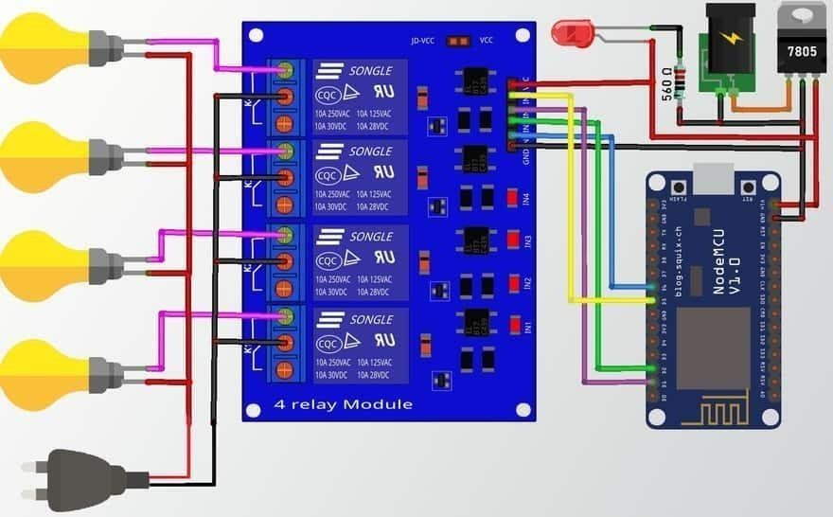

Fig 3.1 System Architecture

## REQUIREMENT SPECIFICATION

* + 1. **HARDWARE SPECIFICATION**

ESP32

Lithium Ion Battery

5V Double channel Relay module Breadboard

## SOFTWARE SPECIFICATION

Arduino IDE Windows 11

My Home App

## COMPONENTS USED

### ESP32 :

The ESP32 microcontroller has emerged as a powerful tool for home automation, offering a compact yet versatile solution for controlling smart devices. With its built-in Wi-Fi and Bluetooth capabilities, the ESP32 seamlessly connects to various IoT devices, enabling users to remotely monitor and manage their homes.

### 5V Double Channel Relay Module:

A relay module is an electromechanical switch used to control high-power electrical devices using a low-power signal, such as from a microcontroller like the ESP32. The double-channel relay module used in the system can control two separate electrical circuits. Each channel typically consists of a control input and two output terminals for connecting the device to be controlled (e.g., a bulb or a fan).

**Bulb and Fan:**

These are examples of electrical devices that can be controlled using the relay module. The bulb represents a simple lighting fixture, while the fan represents a motor-driven appliance.

The relay module acts as a switch, allowing the ESP32 to turn the bulb or fan on/off by controlling the flow of electricity to them.

### Jumper Cables:

Jumper cables are used to create electrical connections between components on a breadboard or between components and the ESP32.

They typically consist of insulated wires with male or female connectors on each end, making them versatile for connecting different components in a circuit.

### Breadboard:

A breadboard is a prototyping tool used to create temporary circuits without the need for soldering. It consists of a grid of interconnected metal strips embedded in a plastic base.

Components can be inserted into the holes on the breadboard, and jumper cables can be used to make connections between them, allowing for quick and easy experimentation and testing of circuits.

### Bluetooth Module:

A Bluetooth module enables wireless communication between the ESP32 and external devices, such as smartphones or tablets.

A breadboard is a prototyping tool used to create temporary circuits without the need for soldering. It consists of a grid of interconnected metal strips embedded in a plastic base.

Components can be inserted into the holes on the breadboard, and jumper cables can be used to make connections between them, allowing for quick and easy experimentation and testing of circuits.

## WORKING PRINCIPLE

The proposed home automation system revolves around the ESP32 microcontroller board, serving as the system's central control unit. Programmed instructions executed by the ESP32 dictate communication with relay modules, enabling regulation of power to electrical devices like bulbs and fans. Relay modules act as intermediaries, isolating the ESP32’s low-power signals to control the high-power circuits of these devices, facilitating their activation and deactivation as needed.

Facilitating remote control and accessibility, a Bluetooth module enables wireless communication between the ESP32 and external devices like smartphones or tablets. Through a dedicated mobile application interface, users can seamlessly issue commands to the ESP32 via Bluetooth, facilitating remote control and automation of household devices from their mobile devices. This intuitive interface enhances user convenience, providing flexibility in managing the home environment efficiently.

The system prioritizes simplicity and accessibility, utilizing readily available components and open-source software to ensure affordability and ease of maintenance. Its modular design allows for scalability, accommodating the integration of additional devices and functionalities as required. Overall, the proposed home automation system offers a comprehensive solution for modernizing home management, catering to the diverse needs of homeowners seeking enhanced convenience and efficiency in their daily routines.

Facilitating remote control and accessibility, a Bluetooth module enables wireless communication between the ESP32 and external devices like smartphones

## CHAPTER 4 RESULT AND DISCUSSION

* 1. **ALGORITHM**

The algorithm orchestrates the home automation system's functionality, starting with initialization where the ESP32 and relay modules are set up for communication. Following this, connectivity between the ESP32 and the Bluetooth module is established to enable wireless interaction with external devices. Entering a loop, the system continuously monitors for commands from the mobile application via Bluetooth. Upon receiving a command, it decodes the instruction to determine the intended action, such as toggling a device on or off. Subsequently, the corresponding relay module is activated to control the power supply to the designated electrical device based on the received command. To ensure user feedback and status updates, the system transmits confirmation messages to the mobile application. This loop persists, allowing the system to remain responsive to user inputs and continuously monitor for new commands. Finally, upon completion of tasks or at the user's request, the system gracefully shuts down, releasing any allocated resources. This algorithm streamlines the operation of the home automation system, providing users with a seamless and efficient means of controlling household devices remotely.

|  |  |
| --- | --- |
| **Component** | **Function** |
| ESP32 | Acts as the microcontroller for system control and facilitates communication with the mobile application. |
| Mobile Application | Serves as the user interface, allowing remote control of connected devices. |

|  |  |
| --- | --- |
| Sensors | Monitor environmental conditions such as temperature, humidity, and occupancy. |
| Relay Modules | Actuators used to control various household devices (lights, appliances) based on sensor data. |
| Power  Supply | Provides electrical power to the ESP32 and connected devices. |
| Internet Connectivity | Enables seamless communication between the mobile application and ESP32, allowing remote device control. |
| Breadboard | Facilitates prototyping and assembling of components. |
| Jumper  Cables | Used for connecting components on the breadboard, aiding in circuit  assembly. |

Table 4.1Component Table

Throughout this process, the system provides feedback to the user via the mobile application, confirming the execution of commands and updating device status. This iterative cycle ensures continuous monitoring of sensor data and responsiveness to user inputs, creating a seamless and user-friendly experience for remotely controlling the home environment.

## IMPLEMENTATION:

The implementation of a smart home assistant with voice recognition involves the integration of cutting-edge technologies to create a seamless and user-friendly interface for controlling and managing various smart devices within a home. At its core, this technology relies on artificial intelligence and natural language processing, enabling the system to understand and respond to spoken commands and queries. To implement such a system, a dedicated hardware device or software application is employed, typically connected to the internet and designed to be compatible with a wide range of smart devices and services. The device's microphone captures voice input, which is then processed through sophisticated algorithms to convert speech into actionable commands. The system can control lights, thermostats, security systems, and a host of other smart devices through voice-activated instructions, providing users with a hands free and efficient means of managing their homes. In summary, implementing a smart home assistant with voice recognition involves the integration of AI, NLP, and compatibility with various smart devices to create a convenient and connected home environment. This technology not only simplifies daily tasks but also offers opportunities for energy efficiency, accessibility, and improved overall living experiences.

Integration follows, ensuring seamless interaction between hardware and software components. Firmware is connected to the hardware setup, and communication between components is rigorously tested to validate accuracy and reliability. The mobile application is also integrated with the ESP32, undergoing thorough testing to confirm proper Bluetooth connectivity and command execution.

Testing and debugging play a vital role in the implementation phase. Comprehensive tests are conducted to evaluate the entire system, including hardware, firmware, and the mobile application. Unit and integration tests verify component functionality and coherence. Any encountered issues are meticulously debugged and resolved, ensuring system robustness.

Upon successful testing, the system is deployed, accompanied by user documentation and training to enable efficient system operation. Post- deployment, the system is monitored for performance, and necessary enhancements are implemented to optimize functionality and user experience. Through this systematic approach, the voice activated electronics is effectively implemented, offering users convenient and efficient control .

## CHAPTER 5 OUTPUTS

* 1. **OUTPUT:**

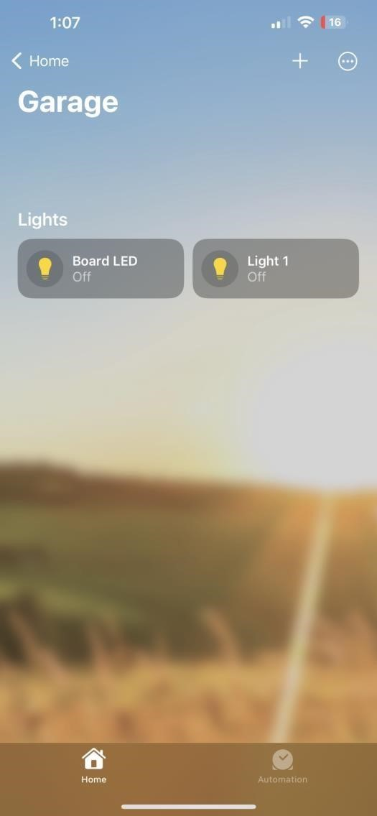

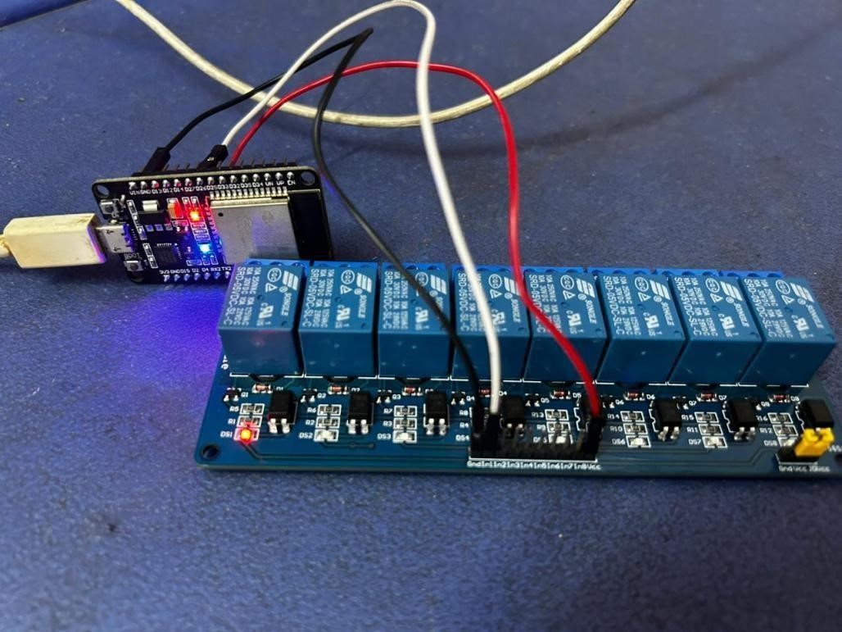

## SECURITY MODEL:

The security model for the voice activated electronics system prioritizes safeguarding user privacy, data integrity, and system accessibility. Central to this model is robust authentication, employing methods like password-based, biometric, or multi-factor authentication to verify user identities. Encryption techniques are then employed to secure communication between the mobile application and the ESP32, as well as between the ESP32 and external devices, ensuring confidentiality of transmitted data. The IoT Connectivity Module facilitates communication between the voice-activated device and other connected devices or cloud services. It involves protocols like MQTT, CoAP, or HTTP to transmit data securely. This module enables the device to send and receive information from the Internet, allowing for remote control, updates, and integration with other smart devices in a home or industrial setting. The user authentication and authorization module ensure that only authorized users can access and control the voice-activated electronics. It involves secure authentication mechanisms such as biometrics, passwords, or multi-factor authentication to verify the user's identity. Authorization mechanisms determine the level of access and control a user has based on their credentials. The UI and Feedback Module is responsible for providing a user-friendly interface and feedback system. This includes designing a graphical or voice-based interface through which users can interact with the device. Feedback mechanisms, such as voice responses or visual indicators, inform users about the status of their commands or the device's current state. This module plays a crucial role in enhancing the overall user experience.

## CHAPTER 6 CONCLUSION AND FUTURE WORK

* 1. **CONCLUSION**

The integration of smart home assistants with voice recognition has yielded remarkable results in enhancing the convenience and functionality of modern households. These technologies have revolutionized the way we interact with our living spaces, offering hands-free control over a wide array of smart devices and services. The primary result is an unprecedented level of convenience, where users can simply speak their preferences and commands to manage lighting, thermostats, security systems, and more. This has not only streamlined daily tasks but also contributed to energy efficiency, as users can easily adjust settings to save on utilities. Furthermore, these assistants provide accessibility options for individuals with disabilities, fostering inclusivity and independence. Their continuous learning capabilities mean that they adapt to user preferences, delivering a more personalized and efficient experience over time. In conclusion, the advent of smart home assistants with voice recognition has ushered in a new era of convenience and automation for modern households. These intelligent systems, driven by artificial intelligence and natural language processing, have redefined the way we interact with our living spaces. With their ability to understand and respond to voice commands, they offer seamless control over a wide array of smart devices and services, making daily tasks more efficient and enjoyable. Their compatibility with diverse smart home ecosystems, continuous learning capabilities, and commitment to security and privacy make them invaluable additions to our homes.

## FUTURE WORK

Looking ahead, several promising directions for future work can further elevate the home automation system's capabilities and address emerging needs. Integration of artificial intelligence (AI) and machine learning (ML) algorithms stands out as a transformative avenue. By leveraging AI/ML, the system can evolve from reactive to proactive, anticipating user preferences and automating tasks based on learned patterns and predictive analytics. This could include personalized device scheduling, energy optimization algorithms, and adaptive behavior based on user habits and environmental factors.

Security remains paramount, and future work can focus on enhancing the system's resilience against cyber threats. This involves implementing advanced encryption methods, multifactor authentication, and anomaly detection to safeguard user data and prevent unauthorized access. Moreover, research into blockchain-based solutions could provide tamper-resistant data integrity and decentralized authentication mechanisms, further fortifying the system's security posture.

As the Internet of Things (IoT) landscape continues to expand, interoperability becomes increasingly crucial. Future efforts may center on standardizing communication protocols and promoting device compatibility across diverse ecosystems. This ensures seamless integration with a wide array of smart devices and platforms, fostering a cohesive and interconnected smart home ecosystem.

Energy efficiency remains a key concern, and future work can explore novel approaches to optimize energy consumption within the home automation system. This includes developing intelligent algorithms to dynamically adjust device settings based on real-time energy demand, occupancy patterns, and

renewable energy availability. Additionally, integration with smart grid technologies enables demand response strategies, allowing the system to intelligently manage energy usage in response to grid conditions and pricing signals.

User experience enhancements represent another promising area of future work. This involves refining the mobile application interface with intuitive controls, personalized dashboards, and interactive visualization tools. Additionally, incorporating voice recognition and natural language processing capabilities can offer users more intuitive and hands-free control over their smart home devices.

In conclusion, future work on the home automation system holds great potential to further enhance its intelligence, security, interoperability, energy efficiency, and user experience, ultimately advancing the vision of seamless and intelligent living spaces.

User experience enhancements represent another promising area of future work. This involves refining the mobile application interface with intuitive controls, personalized dashboards, and interactive visualization tools. Additionally, incorporating voice recognition and natural language processing capabilities can offer users more intuitive and hands-free control over their smart home devices.

In conclusion, future work on the home automation system holds great potential to further enhance its intelligence, security, interoperability, energy efficiency, and user experience, ultimately advancing the vision of seamless and intelligent living spaces.

## REFERENCES

[1] Bingol O, Tasdelen K, Keskin Z, Kocaturk YE. Web-based smart home

automation: PLC-controlled implementation. Acta Polytechnica Hungarica. 2014 Jan

1;11(3):51-63.

[2] Edgerton D. Shock of the old: Technology and global history since 1900. Profile

books; 2011 May 26.

[3] Korzun DG, Borodin AV, Timofeev IA, Paramonov IV, Balandin SI. Digital

assistance services for emergency situations in personalized mobile healthcare:

Smart space based approach. In2015 International Conference on Biomedical

Engineering and Computational Technologies (SIBIRCON) 2015 Oct 28 (pp. 62

67) IEEE.

[4] Wang Y, Zhu J, Zheng T, Gao F, Guo X. Comparing three smart device setups for

the use of speech interface in destination search while driving. 2015.

[5] Cheung E, Markman V, Gava F, inventors; Samsung Electronics Co Ltd,

assignee. Smart home connected device contextual learning using audio

commands. United States patent application US 14/672,667. 2016 Aug 4.

[6] Groover MP. Fundamentals of modern manufacturing: materials processes, and

systems. John Wiley & Sons; 2007 Jun 14.

[7] Kadam R, Mahamuni P, Parikh Y. Smart home system. International Journal of

Innovative research in Advanced Engineering (IJIRAE). 2015.

## APPENDIX

